Scenario:

In this lab, I will use some system commands to explore the file system

Copy a file to a new folder.

* + Create a new folder in the E: drive named **Graphics**.
  + Copy **D:​\​Graphics​\​cat.jpg** to the **E:​\​Graphics** folder.

* Use **nslookup** to query the DNS for the CorpServer server using its full name (CorpServer.CorpNet.local).

* Use **chkdsk** to check the file system on the **D: Data** volume.

* Use **gpupdate** to apply the latest Group Policy changes to your workstation.

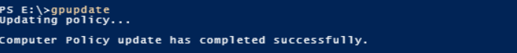

* + Use **gpresult /r** to see which policies are applied to the workstation.

* Use Task Manager to identify the process ID (PID) for the Language Application (**PID=712** in this example and it can be seen in **Details** tab); then use **taskkill** to stop that process.



* Use **net use** to map the P: drive to the Personnel shared folder on CorpFiles.

